LilyPad Basics
Introduction: What are Lilypads?

LilyPad is a wearable e-textile technology developed by Leah Buechley and cooperatively designed by Leah and SparkFun. Each LilyPad was creatively designed to have large connecting pads to allow them to be sewn into clothing. Various input, output, power, and sensor boards are available. They're even washable!

Great, how do we use them:

Utilizing conductive thread we can connect power to different component boards, but to start we need to cover a few basics of circuit design. In building basic circuits, there are two types of configurations: a parallel and series circuit.
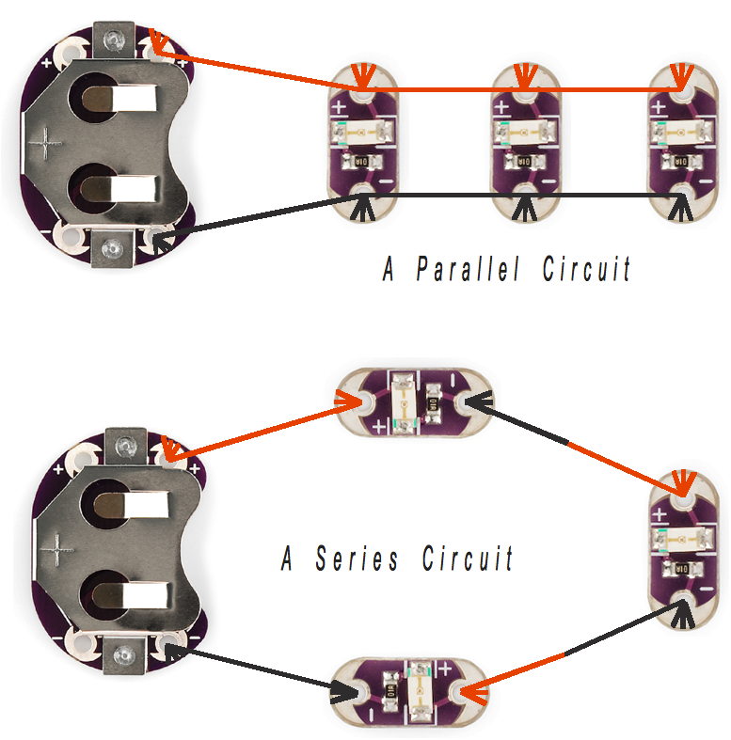
Both have advantages and disadvantages. The largest disadvantage to a series circuit is that you need a high voltage battery to run even a small circuit. Due to this fact, it is recommended that you always use Lilypads in a parallel circuit.

Linking batteries in Series combines the voltages of the batteries to create a power supply with a higher voltage.

Linking batteries in Parallel combines the current of the batteries to create a power supply with a higher Amperage.
Up Next: Battery life!

Before you start it is a good idea to pick all your components and figure out how long a typical battery will run them. For this we will need to do a little, easy math. The first thing to do is to figure out how much current (I) each component will use. In the parallel circuit above, each LED draws about 20 mA (milli-Amps). Since there are three LEDs we need to account for all of them: 20 mA + 20 mA +20 mA = 60 mA. Then we need to find how how many amps the battery holds. For the coin cell battery, this is 250 mAh (milli-Amp hours). This means the battery will run at 250 milli-Amps for one hour. In order to discover how long your battery will run use this equation:

Battery run time = mill – Amp hour of the battery
total milli – Amps of the circuit

For the circuit above:

- Total milli-Amps of the circuit = 20 mA +20 mA +20 mA so...
Total milli-Amps of the circuit = 60 mA
- Milli-Amp hour of the battery = 250 mAh
- Using these two values in the equation above-
Battery Run time = 250 mAh so... Battery Run time = 4.167 hours
60 mA

Now we know about how long one coin cell battery can power 3 LEDs. If the battery run time you come up with is not long enough, there are some other options available to you. The Lilypad line has various components designed to allow you to plug in different types of batteries.
Enough science, let's get to the fun part: LilyPad basics

Do not sew any components in with the battery installed. There is no risk of getting hurt, but you might kill the battery.

There are generally two types of thread, thick and thin. The thick type is better if you are going to have LEDs far away from the battery. The thin type will work in a sewing machine but the components cannot be too far away from the battery.

Any time you make a connection between a component and the thread, make a few loops through the connection hole. The section of metal on the outside of the connection is hole is where the electricity will flow between the thread and the component. Often if there is a short, or break, in your circuit it is because the conductive thread does not always touch this piece of metal on the component. It is possible to sew the thread through the connection without touching this piece of metal and the thread, so make sure to double check your connections.

The thread will melt similar to nylon. It is good to knot the end of your thread at a component and melt the extra, however be careful you do not burn your project.

If you have two threads that need to cross, there must be some fabric between the two otherwise the circuit will not work.

There are other conductive e-textile materials such as buttons, fabric, yarn, paint and velcro. There are many different ways to use the materials as switches, sensors and circuits, you just need to experiment.
Sewing the circuits:

Not everyone has a background that involves sewing, so here are some basics on sewing to get you started.

Threading the needle:
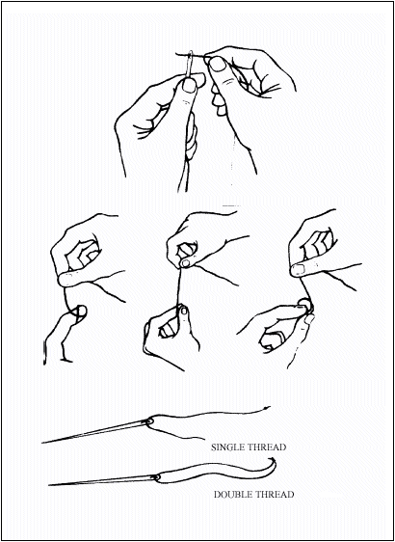  Photo from CIEhub.info. | Threading the needle- at the best of times, threading a needle is a frustrating task, particularly if your eyesight is less than perfect, or your hands aren't entirely steady. Conductive thread is a little bit more difficult than traditional thread, because it's frequently thicker, and frays more easily. Cutting a new end on the thread right before threading will remove any frays, and running the end of the thread through quilting beeswax will help hold it together and stiffen it, making it easier to thread. Follow the steps below. When you're working with e-textiles, the decision to use single or double thread (shown at the bottom of the picture) is a little bit more complicated than it would be with traditional textiles. The thread you're working with has a resistance, usually between a few ohms per foot and several hundred ohms per foot, depending on how thick the thread is and what the metal content is. The higher the resistance is, the more limited the power will be that reaches your components. That means that if you have 3 feet of thread between your battery and a light in your circuit, and the thread is very high resistance, the light might not even come on. More thread can decrease the resistance by providing more conductive material- that means that if your thread is 100 ohms per foot, and there's a foot of thread between the battery and the light, a single thread is going to add 100 ohms of resistance and a double thread is going to add only 50 ohms of resistance. On the whole, it's nice to keep resistance to a minimum- where your thread and fabric allow it, going ahead and doubling the thread is an easy way to do that. Still, there are some threads that are too thick to conveniently double, or low enough resistance that it's not necessary, so try to weigh the resistance against the bulk and make the decision that is practical for your project.
Stitching:

There are a few basic stitches that can be really handy.

A Running Stitch is a very simple, fast, and easy stitch, great for connecting components where it's unimportant whether your thread is visible.
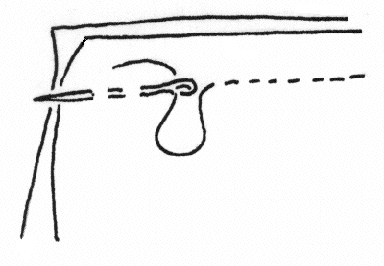
A Basting Stitch is a very wide stitch, best used where you need to cover a lot of ground quickly, on last-minute projects, and when you're confident that the stitching won't be seen or won't have to last long. Basting stitches give you amazing speed payoff, but very little durability, so use them wisely.
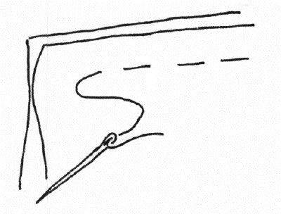
A Blind Stitch is a great way to conceal your stitching in a project where you don't want the conductive thread to clash with the face of the project. If you're working with two layers of fabric, you can put several solid stitches in the back layer for every one stitch that barely nicks through the top layer of fabric. With only one layer, use a large basting stitch on the back of the fabric, then nick through to the front in a very small stitch. Done well, this technique will make your stitching invisible from the front, which is nice in projects where the dark gray of conductive thread won't blend well.
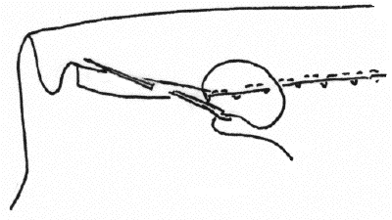
Stitching pictures above by www.ia470.com

Ohm’s Law:

Ohm’s Law is a simple equation that explains the relationship between current, voltage and resistance. It is important to understand because the amount of resistance (how hard it is for electrical current to pass through a material) in your thread and other conductive materials will affect the amount of current and voltage available to your sensors and Micro-Controller Input pins.
Here is the equation:
V = I * R or I = V / R or R = V / I

In this equation V is Voltage, I is Current and R is Resistance. This means that the less resistance your circuits (which include the conductive thread) provide the more electricity there will be available to be used by your components. You can also use the amount of resistance that your materials provide as a sensor. One example of this is detailed in the next section More Concepts with LilyPad and Conductive Materials.
It also means that you can double up your thread by stitching through the same area multiple times in order to decrease resistance. Doubling up your thread decreases resistance because the electricity has more material it can flow through. In order to decrease the amount of resistance you will need to double up all the areas in a circuit where you stitched conductive thread, it will not work if you fail to double up even one section of the circuit.
More Concepts with LilyPad and Conductive Materials
Making flower button circuits:
These instructions can be used to create a variety of switches- not just the one I've made here. Feel free to change it up and make a button that works with your project, such as a cat button with conductive thread whiskers you can stroke or a guitar button with strummable strings!
The type of switch you're making is called a 'momentary' button or switch. What that means is that you're only momentarily making a connection. When you bring the thread in contact with the fabric, you are creating a path for electricity that lasts only as long as the thread and fabric are in contact. When you take your hand away, the thread will spring back to its original position, and you will no longer have a closed circuit. On a practical level, this means that you can sew the switch into a circuit and use it to turn something on. If the switch is placed, for instance, between a power supply and an LED, the light will turn on while you are activating the switch, and off again as soon as you stop pressing the thread and fabric together.
Materials:
This list is to create the switch pictured; the only real constants if you want to change the style of the switch are conductive thread, conductive fabric, a non-conductive material to insulate between them, and an adhesive.
Conductive Fabric
Conductive Thread
Stiff, Non-conductive fabric (I used felt)
Non-conductive ribbon
Hot Glue
Chenille Needle
First, cut about 15 small strips of ribbon, roughly as long as you'd like the longest point of your flower petals to be. Mine were about 2 inches long, but go ahead and customize it to your project. Trim each strip into an oblong with one pointy end and one flat end. I highly recommend having one flat side, as it makes them easier to line up when you're creating your flower, but beyond that, the shape and quantity of the petals is an aesthetic decision- feel free to pack more petals in or change the shape as you see fit!

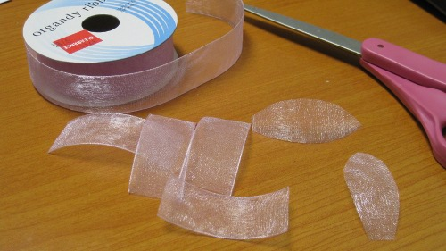
Cut out conductive fabric petals in the same shape, slightly smaller. If you're having problems, try using one of the ribbon petals as a template.

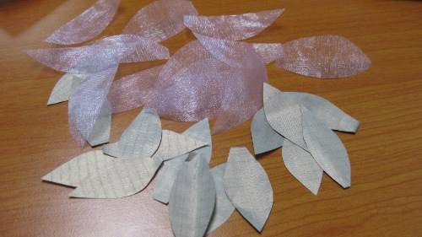

Cut a small piece of your non-conductive fabric. The shape is largely irrelevant, since you'll be covering it with petals, but make sure it's big enough to support two layers of petals and still have room to be sewn or glued to the garment. Glue the non-conductive petals down, overlapping slightly, making sure that you leave a bare circle in the middle.

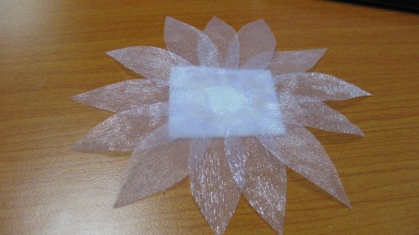

Glue the conductive petals on top of the ribbon petals. Just like the ribbon petals, you want them to overlap, and you want to leave an open circle in the middle. Make sure that you don't use too much glue here- you don't want to insulate the petals. try to make sure that each petal makes uninsulated contact with both of the petals next to it.
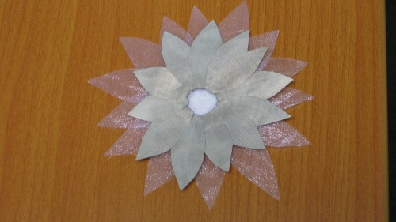

Repeat this process until you have as many flowers as you need for your project
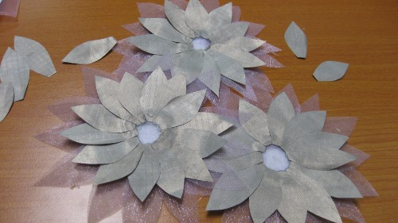
Turn your flower over and glue another conductive petal to the back of the non-conductive fabric, being careful to ensure that the flat edge of the petal overlaps the empty circle in the middle of the flower. You want both tips of the petal free for sewing, so place your dot of glue towards the middle of the petal.
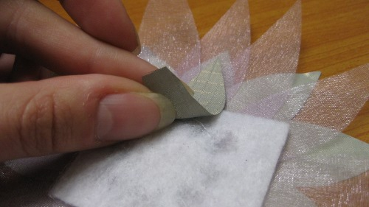
Double check that your bottom conductive petal is in NO CONTACT with your top conductive petals. Ideally, the ribbon petals should insulate between them, but there can be gaps, so check now. If the top and bottom petals touch, your circuit will always be closed, which means that whatever you're controlling with the switch will be always turned on.
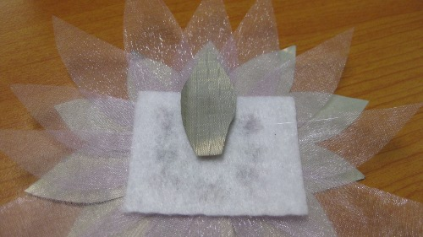
Cut 8 strands of conductive thread, about 3 inches long per flower, and twist them all together. Thread the entire twist through a single needle- this will be easiest with a fairly fine thread, such as the 2-ply conductive, and a large chenille needle, available at craft and fabric stores or in our needle set.
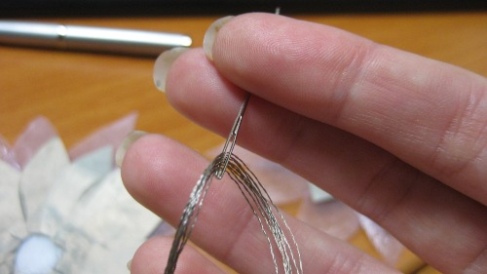

Make one stitch all the way through the bare center of your flower, making sure that it goes through the bottom petal, and back up, without pulling the thread tight- you want about an inch and a half of thread on each side of the stitch, on top of the flower, like a tailor's tack. (Many thanks to Miss P for putting up such a great tutorial on the subject!)

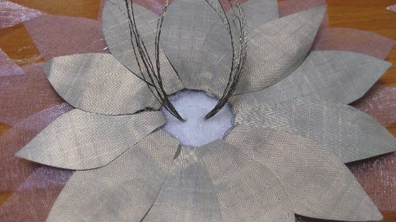

The stitch should be solidly in contact with the back petal, as shown. This is going to create the electrical connection between the two petals and stamen, closing the circuit when the switch is activated.

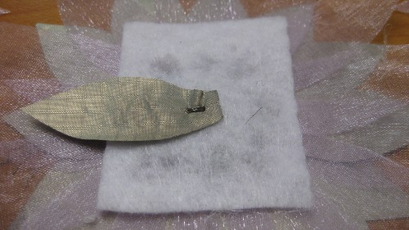

It's important for the stamen to stand up so that it's only in contact with the petals when you brush it. To help ensure this, and also to keep the stitch from coming out, dot a little bit of hot glue in between the two bundles of strands.
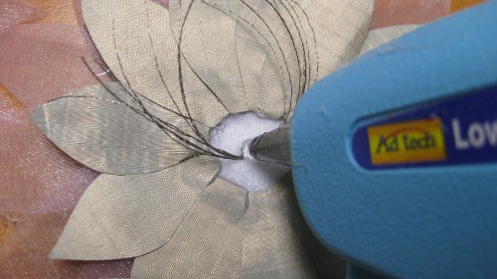

Press both bundles into the blob, being careful not to burn yourself. I'm using a low temperature glue gun, which makes this a little easier.

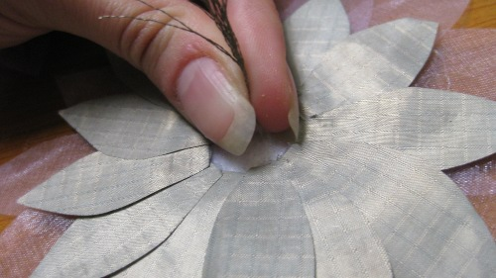

This results in one nice tall bundle of thread poking out of the top of a (slightly unsightly!) blob of glue. Feel free to try another technique here, or cover this junction with glitter, beads, whatever works for you. I left mine alone, because it was pretty small in relation to the whole dress, and unlikely to draw much notice.

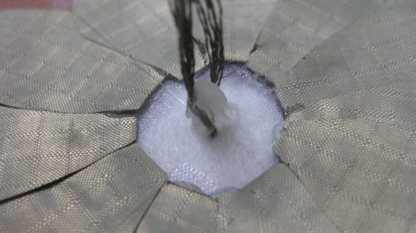

And here are some finished flowers! These can be sewn into a circuit in the same way that you would sew a LilyPad Button Board.

Making potentiometer (AKA voltage divider) circuits:

Potentiometer is just a fancy way of say “dial”. But the reason why we say potentiometer is because this type of sensor can come in many different styles. Below is an explanation of how to create a potentiometer using conductive thread or yarn and some type of conductive claps or circle.

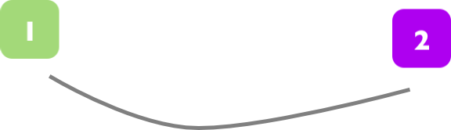 | Step 1: First connect one side of a piece of conductive material to your power source (1) and connect the other side to a ground (2). You may need to dis-attach one of these connections, so make sure you can do so if need be.
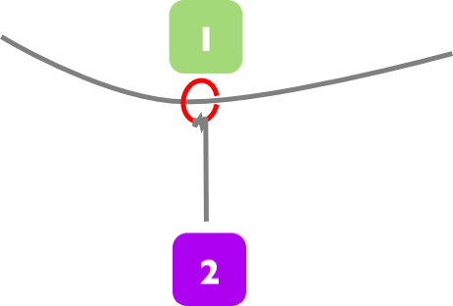 | Step 2: Next place your conductive circular component (a metal ring or jewelry clasp) on the first piece of conductive material (1). The metal ring should be able to move freely on the conductive material while still making constant contact. Bear in mind that this ring will move a lot, so make sure it doesn't wear or fray the conductive material. Tie another piece of conductive material to the metal ring and connect the end of this to an analog Input pin (2). Now as you move the metal ring you will get a different voltage to your Input pin (2) depending on where the metal ring is. The closer the ring is to the power source the higher the voltage you will see on your analog Input pin. The closer the ring is to the grounded connection the lower the voltage you will see on your analog Input pin.

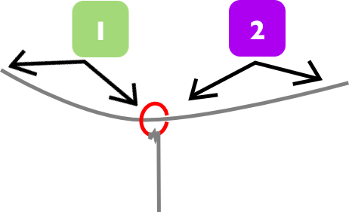 | An explanation: The reason this works is that due to Ohm's Law the voltage will decrease the more resistance the electrical signal passes through before it reaches the Micro-Controller pin. So if it passes through a whole bunch of conductive material (remember, even though it's conductive it also has resistance) before it gets a chance to travel through the metal ring and into the analog Input pin then the signal will be kind of weak.
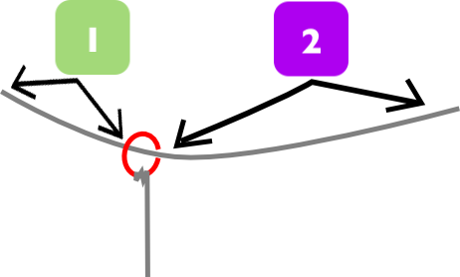 | But if the electrical signal doesn't have to travel through as much conductive material because the metal ring has been moved closer to the power source, then the signal will be stronger because there is less resistance. Here is the equation used by people who like equations to figure out exactly how much voltage will come out of this potentiometer into the analog Input pin:
Potentiometer (AKA Voltage Divider) Equation:  Vout = Vin * R2 / R2 + R1 | In this equation Vout is the electrical signal we are solving for because it represents the amount of voltage we will find running into the analog Input pin. Vin is the amount of voltage the first piece of conductive material is connected to at the power source. R1 is the amount of resistance provided by the first section of the conductive material (1). R1 is the amount of resistance provided by the second section of the conductive material (2).

